# Final Project Proposal

## Can a Modular 3D Player Controller developed in Unity, offer greater accessibility to non-programmers as an industry tool?

**Overview**

Using C# and the Unity development software to create a downloadable player controller capable of being attached to game characters thus enabling easy editing of common attributes.

As a stretch goal, and in addition to common attributes, documentation regarding the application of adding custom attributes to the controller will be produced in the form of step by step instructions. This provides the user greater customisation over the application development with increased adaptability for a variety of game types.

Providing the greatest amount of control to the user is at the forefront of the controller development, therefore testing the implementation of different mechanics will be a continuous task throughout the creation of the controller. C#, the main language of Unity, will be utilised to write the player controller.

**What is a player controller?**

A player controller is a script that is attached to a character of a game which allows the user to enter different values for different character attributes. These can include, but are not limited to, Walking; running and crouching speeds; jump height and the rate at which the character falls and how long it takes for the character to stop moving.

**Player controller applications.**

A player controller facilitates easy development of a game character without diving into the code (Kraczla and Gerasimov, 2012). A variety of character attributes, accessed via the inspector, provide a less experienced user with limited programming knowledge, access to a list of editable character attributes. The values for which can be easily edited by either changing a number or dragging and dropping specific in-game objects to the correct location.

This application mitigates the need for and the risk of the code being altered by a development team member not versed in coding, and the game breaking because of it.

**Proposed attributes**

The proposed attributes listed below make the player controller a more versatile tool across a wide variety of games. However, as the controls and attributes vary from game to game as stated in the stretch goal the user will be able to easily add or remove custom attributes to fit the need of their game.

* Keys/Buttons
  + The user will be able to assign the keys/buttons they want for the different actions the player character has.
  + Mouse sensitivity
* Movement
  + Walking Speed
  + Running Speed
  + Speed when Crouching
  + Minimum distance the character can move
  + Time it takes for the character to stop moving
  + Maximum height something can be for the character to walk up (stairs)
* Jumping
  + Height
  + Fall speed
  + If the character is touching the ground or not (The user will be able to define what the ground is)
* Abilities
  + Health
  + Stamina
  + Charge jump
  + flying
  + Oxygen
* Hitbox
  + Rigid body
  + Centre
  + Radius
  + Height

**Methodology**

The Unity development software will be utilised for this project. An initial basic scene will be constructed including obstacles and one character. An attribute from the aforementioned list will then be chosen for further research into the variety of ways to code it in Unity. The attribute will then be applied to the character and the next one will be chosen. Following testing, the successful method will undergo further comment in the form of a Blog.

Scriptable objects in Unity will be looked into as they are a way of storing large quantities of shared data, meaning that the user will be able to add and change values easily to their different characters.

Investigation of additional attributes and implementation of stretch goal, may be explored if time allows.

**Employment opportunities**

While creating player controllers isn’t a specific job, C# coding in Unity is.

This project provides me the opportunity to showcase my ability to program in C# and Unity, giving future employers a measurable example of my skill level.

Below are some examples of low level Unity jobs found from looking online.

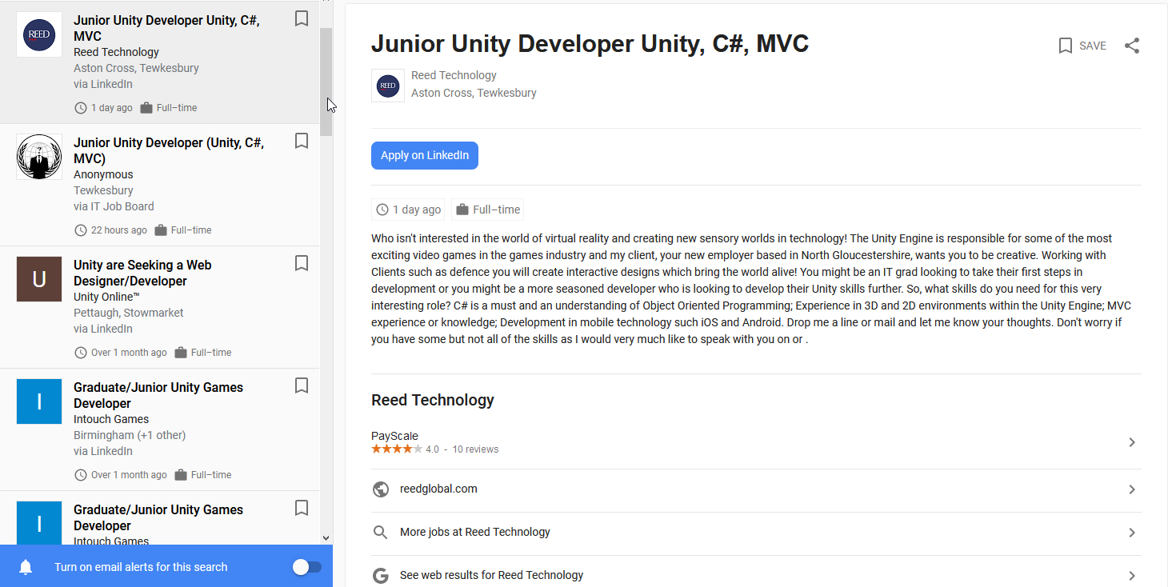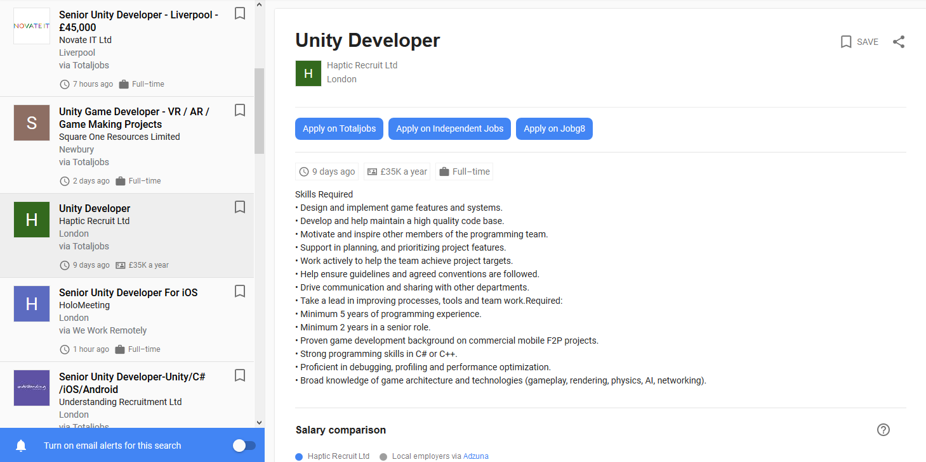

**Management software**

Three main software packages to be used throughout this project’s development are Trello, GitHub and a development blog.

Trello will be utilised to create and track individual tasks for each week. This organisational tool brings order to the project. Tracking tasks at various stages of completion is vital to hitting targets and keeping the project’s progress time-managed.

GitHub will be used for version control and a place to upload work. GitHub is useful as it allows anyone access to view the project and the upload history. GitHub works in such a way that, if anything were to go wrong, it is a quick and easy process to revert to the previous correctly functioning version. GitHub also allows for a better understanding of changes between uploads.

|  |  |
| --- | --- |
| **Week #** | **Milestone Deliverables and Tasks** |
| Week 7 | Submission of final project proposal |
| Week 8 | Start development of the application |
| Week 9 | Research into scriptable objects in Unity. |
| Week 10 | Work on the movement of the character - Walking |
| Week 11 | -Running |
| Week 12 | -Crouch speed |
| **Christmas** | |
|
|
| Null |  |
| Null |  |
| Week 13 | Work on the ability to assign custom keys to the movement of the character |
| Week 14 | Jumping |
| Week 15 | Fall speed |
| Week 16 | Health and stamina |
| Week 17 | Work on adding in controlling the view port with the mouse (first and third person) |
| Week 18 | Hitbox |
| Week 19 | -Height |
| Week 20 | -Radius |
| Week 21 | Work on the documentation to enable custom adding of attributes |
| Week 22 | -Documentation |
| Week 23 | Check over work before submitting |
| Week 24 | Submission of final project |
| **Easter Holiday** | |
|

A development blog will be used to track work completed for the project each week. The blog will include images and descriptions showing progress and change. This tool enables accessible updates to individuals needing to view the project’s progress, as well as enabling access to my reasoning behind choices and specific actions and allowing reflective practice.

**Project Milestones**

Overall wordcount: 935 words.

Student Name: Ethan Ward-Taylor

Proposed Final Project title: Can a Modular 3D Player Controller developed in Unity, offer greater accessibility to non-programmers as an industry tool?

Development Blog URL: <https://ethanwardtaylor.weebly.com/final-project>

**Annotated Bibliography**

|  |  |  |
| --- | --- | --- |
|  | **Bibliography Item** | **Summary** |
| **1** | Youtube.com. (2019). *YouTube*. [online] Available at: https://www.youtube.com/watch?v=BBS2nIKzmbw [Accessed 7 Nov. 2019]. | **A tutorial on making a character controller in Unity 3D** |
| **2** | Youtube.com. (2019). *YouTube*. [online] Available at: https://www.youtube.com/watch?v=3uOdm2wt43E [Accessed 7 Nov. 2019]. | **Going over Unity Character controllers** |
| **3** | Youtube.com. (2019). *YouTube*. [online] Available at: https://www.youtube.com/watch?v=AEPI5rmg3XY [Accessed 7 Nov. 2019]. | **Comparing Rigidbody vs Character Controller in Unity3D** |

## References

Answers.unity.com. (2019). *Proper use of Character Controller - Unity Answers*. [online] Available at: https://answers.unity.com/questions/1264774/proper-use-of-character-controller.html [Accessed 7 Nov. 2019].

Kraczla, D. and Gerasimov, V. (2012). *Unity 3.x Scripting: Write Efficient, Reusable Scripts to Build Custom Characters, Game Environments, and Control Enemy AI in Your Unity Game (Community Experience Distilled)*. Packt Publishing, p.Chapter 1: Available Character Controllers.

Medium. (2019). *Unity: CHARACTER CONTROLLER vs RIGIDBODY*. [online] Available at: https://medium.com/ironequal/unity-character-controller-vs-rigidbody-a1e243591483 [Accessed 7 Nov. 2019].

Technologies, U. (2019). *Unity - Manual: Character Controller*. [online] Docs.unity3d.com. Available at: https://docs.unity3d.com/Manual/class-CharacterController.html [Accessed 7 Nov. 2019].

Unity Learn. (2019). *Recorded Video Session: 2D Platformer Character Controller - Unity Learn*. [online] Available at: https://unity3d.com/learn/tutorials/topics/2d-game-creation/player-controller-script [Accessed 7 Nov. 2019].